**Requirements**

* User can sign up to become a member. The member account will have typical information such as name and E-mail, contact number. An automatically generated User ID number will be given to the account upon creation.
* Member can login to account to either view account page or to create a new ad for now.
* Member can create an ad with equipment information, 1 required picture maximum only for now, required email address for contact, optional phone number for additional contact, date ranges for renting, the renting location, and requested price per day to rent. Ads will have an automatically generated and unique Ad ID number.
* User can browse equipment for rental ads, choose one to go to the ad’s page, and can view all of the details of the equipment to possibly contact the owner.

**Domain Model**

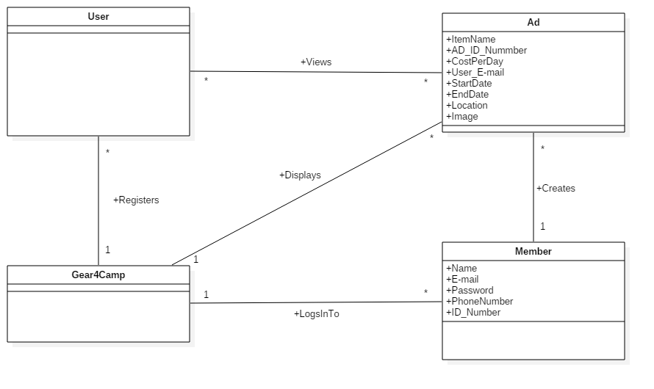

**Supplementary Specification**

* Users must be able to view all available ads.
* Clicking an ad will bring the user to a new page to display more details about the ad.

**Tools Used**

* GitHub: Source code and documentation repository
* Eclipse: Development environment
* Trello: Project tracking and management
* Google Docs: Document Collaboration
* UML Design: Creately, Visio

**Technologies Used**

* Java, JSP, Servlets, HTML, CSS
* Server: Apache Tomcat
* Database: MySql

**Glossary**

* **User:** Someone who uses the Gear4Camp website without creating an account. I.e. they can view and choose ads that they may be interested in, but cannot create ads themselves.
* **Member:** A user who creates an account and can create ad postings to rent out equipment.
* **Ad**: Created by a member to advertise equipment available to rent. It includes various details about the equipment and various policies for renting (dates, price, etc.).

**Business Rules (Domain Rules)**

**Artifacts**

|  |  |  |  |  |  |
| --- | --- | --- | --- | --- | --- |
| **Discipline** | **Artifact** | **Inception (Iteration 1)** | **Elaboration (Iteration 1)** | **Construction (Iteration )** | **Transition (Iteration)** |
|  |  |  |  |  |  |
| Business Modelling | Domain Model |  | S, R |  |  |
|  |  |  |  |  |  |
| Requirements | Use Case Model |  |  |  |  |
|  | Use Case Text | S |  |  |  |
|  | Use Case Diagram | S |  |  |  |
|  | System Sequence Diagram |  |  |  |  |
|  | Vision |  | S |  |  |
|  | Supplementary Specification |  |  |  |  |
|  | Glossary |  | S |  |  |
|  |  |  |  |  |  |
| Design | Class Diagram |  | S |  |  |
|  | Interaction Diagram |  |  |  |  |
|  | Sequence Diagram |  |  |  |  |
|  | Communication Diagram |  |  |  |  |
|  |  |  |  |  |  |
| Implementation | Code |  | S |  |  |
|  |  |  |  |  |  |
| Testing | Test Case Plan |  |  |  |  |
|  | Unit Testing |  |  |  |  |
|  | System Testing |  |  |  |  |